**Experiment No:6**

**Demonstration of working principle of Air Conditioning cycle**

**Introduction:**

**Air conditioning** is the process of removing heat and moisture from the interior of an occupied space to improve the comfort of occupants. Air conditioning can be used in both domestic and commercial environments

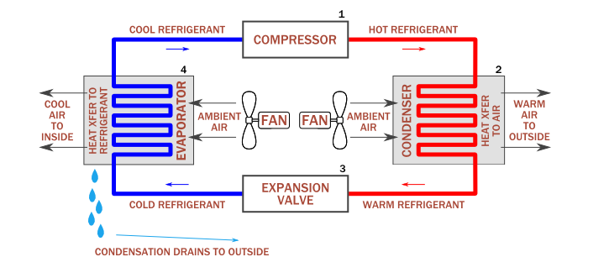

Fig no 6.1:Diagram of working principle of AC cycle

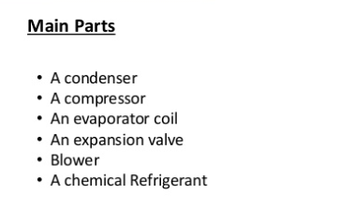

**Condenser:**

The **condenser** removes heat given off during the liquefication of vaporized refrigerant as shown in fig(6.1). Heat is given off as the temperature drops to condensation temperature. Then, more heat (specifically the latent heat of condensation) is released as the refrigerant liquefies.

**Compressor:**

The compressor is the heart of the system. Just like your heart pumps blood through your body at a specific flow rate and pressure, the compressor pumps the refrigerant through the air conditioning system at a designed flow rate and pressure. When the refrigerant enters the compressor it is in a vapor state.

**Evaporator:**

An air conditioner's evaporator coil, also called the evaporator core, is the part of the system where the refrigerant absorbs heat. That is, it's where the cold air comes from.

**The Expansion Valve:**

  The expansion valve removes pressure from the liquid refrigerant to allow expansion or change of state from a liquid to a vapor in the evaporator. Under a greatly reduced pressure the liquid refrigerant is at its coldest as it leaves the expansion valve and enters the evaporator. Evaporator coil is located inside or near the air handler where the blower fan is located as shown in fig(6.1).

**Blower:**

Air conditioner blower or fan is one of the key components that is needed as part of the air conditioning system. The function of the blower is to produce air movement to the space that is being conditioned. There are basically four types of fan that are commonly used in the HVAC equipment.

**A chemical Refrigant:**

Inside an air conditioning system is a chemical refrigerant which is a compound that easily changes states from liquid to vapor and back again. In addition to refrigerant, an air conditioning system requires a minimum of four components, the compressor, condenser, metering device, and evaporator.

**Working Principle of AC cycle:**

The **working principle** of the Air conditioner or **AC** is collecting hot air from a gives spaces and processing it to release cool air into the same space where the hot air had originally been collected. This process is done through the 5 steps such as the evaporator, compressor, condenser, expansion valve, Refrigerant.

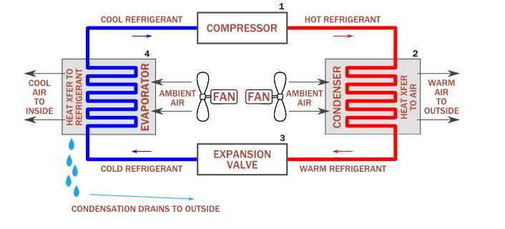

Fig no 6.2: Working cycle of AC

**TS Diagram:**

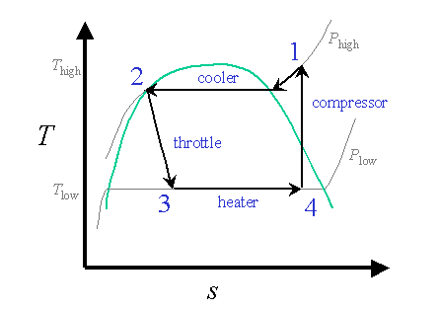

Fig no 6.3: TS diagram of AC cyle

**PV Diagram:**

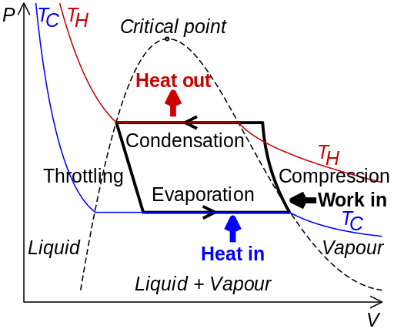

**Differences Between Air Conditioning & Refrigeration:**

In many ways air conditioning and refrigeration systems are very similar. Both use specially designed chemicals, the physical effects of the compression and expansion of gases, and the conversion of gas to liquid to reduce the temperature of air. The varying uses of these systems, however, mean refrigeration and air conditioning systems have a handful of key differences in the design and operation.

**Uses:**

It is used in :

* Industries
* Cold Storage
* In Houses
* Cooling Of electronic spaces and equipment
* Cooling of Electronic spaces and Equipment